DATA ANALYSIS INTERNSHIP – DAY 13 REPORT
Organization: Top Tech Developers
Topic Covered: Comparison Graphs, Bubble Chart, Funnel Chart & Pyramid Chart using Matplotlib
On Day 13 of the internship, different graph visualization techniques were practiced using Matplotlib in Google Colab. Various graphs such as comparison line graphs, bubble charts, funnel charts, and pyramid charts were created to understand graphical representation and visual analysis of datasets.

Introduction
Matplotlib is a Python library used for creating graphs and data visualizations. It helps compare datasets and represent numerical values graphically for better understanding and analysis.
Import Statement
import matplotlib.pyplot as plt
Purpose
- Used for creating graphs and charts
- Helps visualize data clearly
- Supports comparison and analysis of datasets

Task 1 – Comparison of X with Y and X with Z using Line Graph
A comparison graph was created using two different datasets.
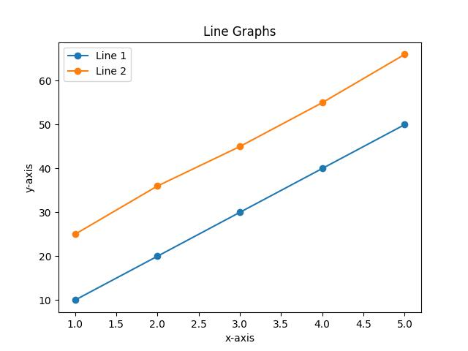
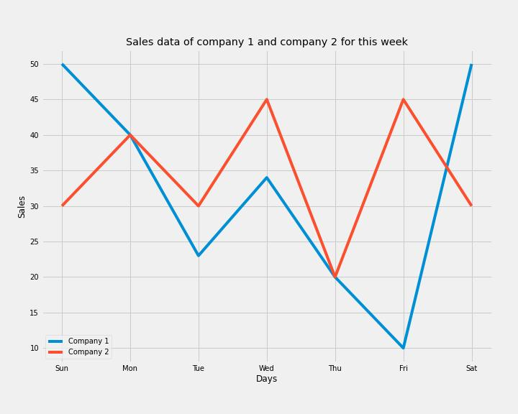
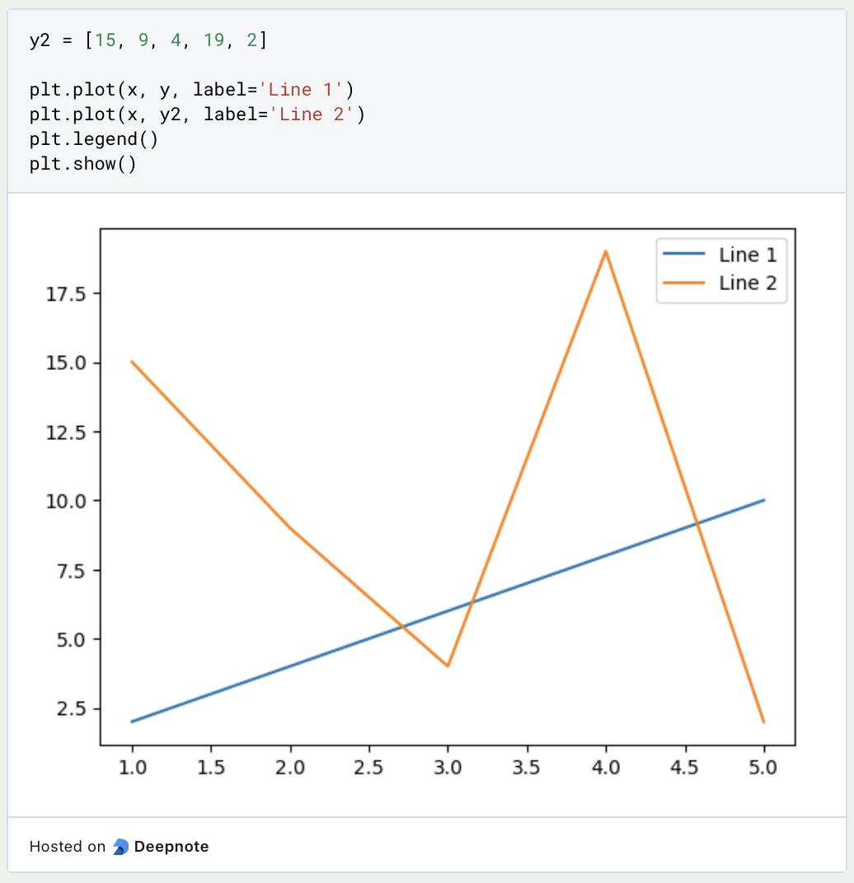
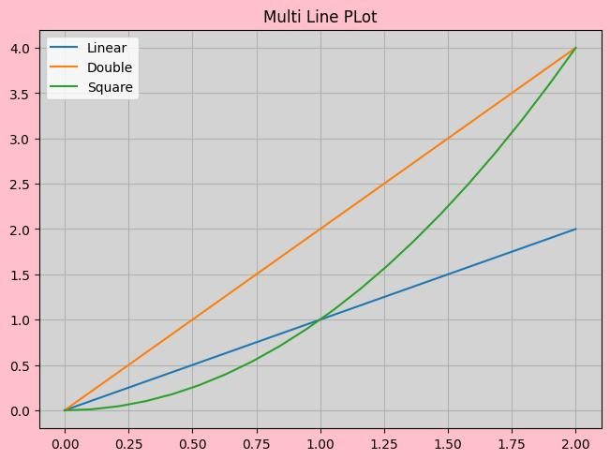
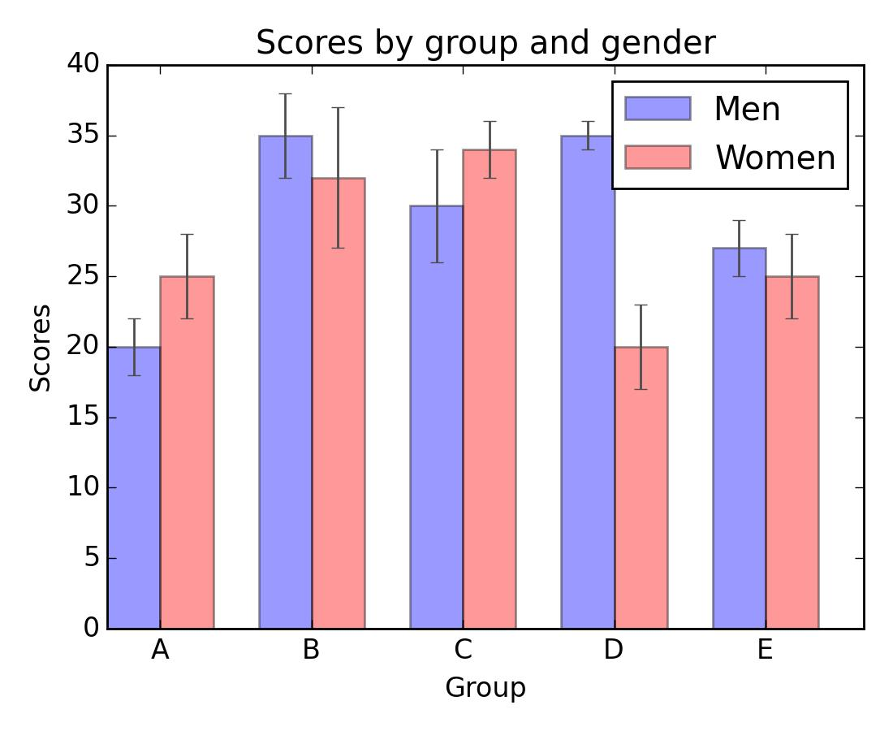
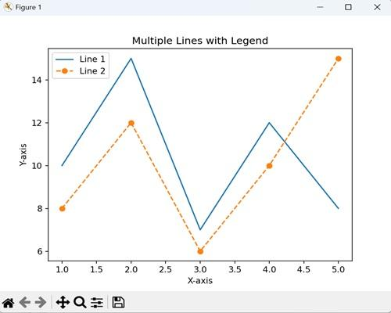
Program
import matplotlib.pyplot as plt

x = [1,2,3,4,5]
y = [10,20,30,40,50]
z = [15,25,35,45,55]

plt.plot(x,y,label="X vs Y")
plt.plot(x,z,label="X vs Z")

plt.xlabel("X Values")
plt.ylabel("Y and Z Values")
plt.title("Comparison Graph")

plt.legend()

plt.show()

Functions Used
Function | Purpose
plt.plot() | Creates line graph
plt.xlabel() | Adds X-axis label
plt.ylabel() | Adds Y-axis label
plt.title() | Adds graph title
plt.legend() | Displays graph labels
plt.show() | Displays the graph

Output Description
- X vs Y is displayed as one line
- X vs Z is displayed as another line
- Helps compare two datasets visually

Task 2 – Bubble Chart using Matplotlib
A bubble chart was created using scatter plot with different bubble sizes.
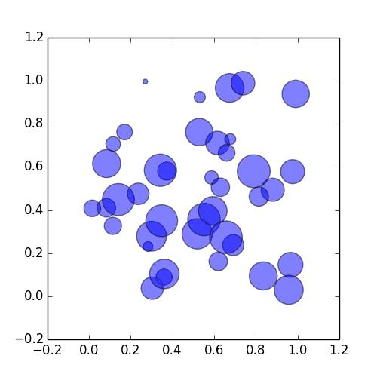
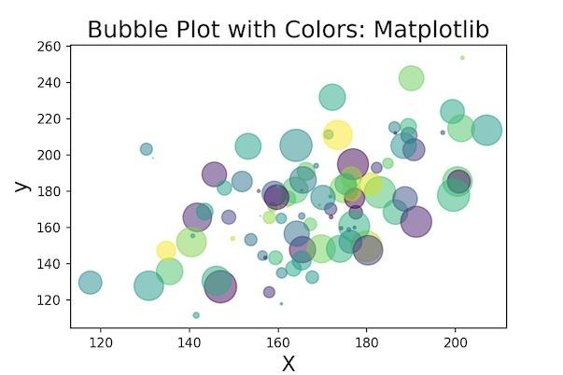
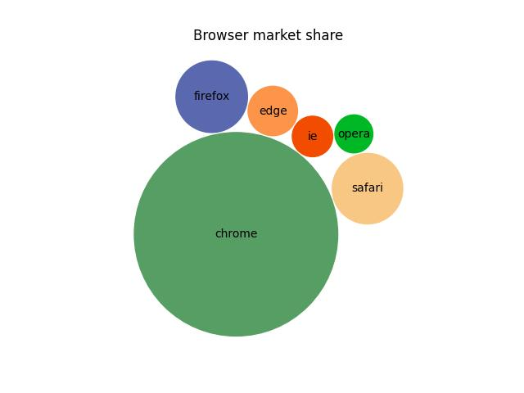
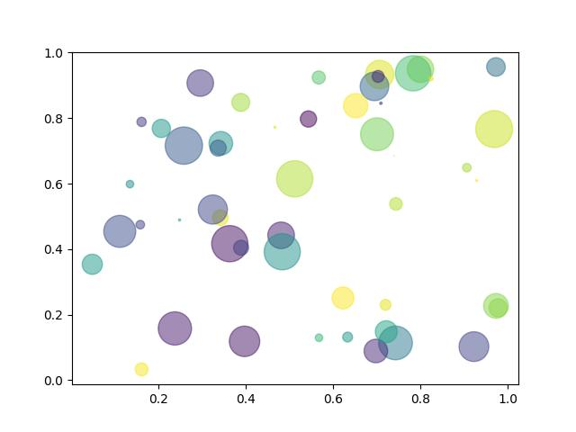
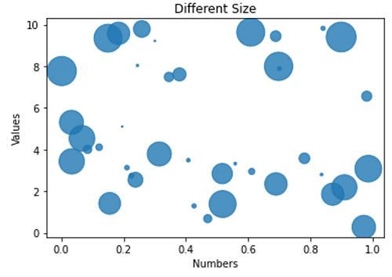
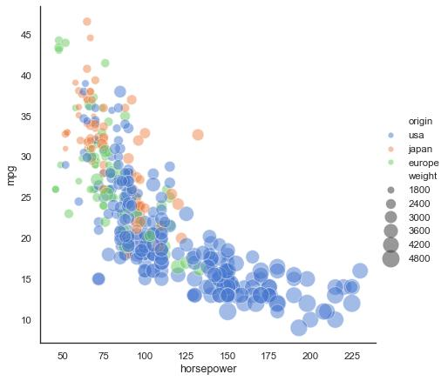
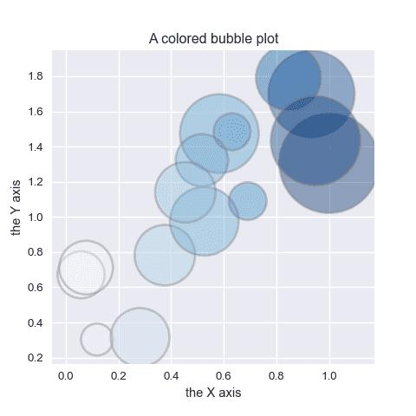
Program
import matplotlib.pyplot as plt

x = [1,2,3,4,5]
y = [10,20,30,40,50]

size = [100,200,300,400,500]

plt.scatter(x,y,s=size)

plt.xlabel("X Values")
plt.ylabel("Y Values")
plt.title("Bubble Chart")

plt.show()

Functions Used
Function | Purpose
plt.scatter() | Creates bubble/scatter graph
plt.xlabel() | Adds X-axis label
plt.ylabel() | Adds Y-axis label
plt.title() | Adds graph title
plt.show() | Displays graph

Output Description
- Bubble chart is displayed using scatter plot
- Each point has different size based on the size list
- Represents relationship between X and Y with magnitude

Task 3 – Funnel Chart using Matplotlib
A funnel chart was created to represent user flow and reduction at each stage.
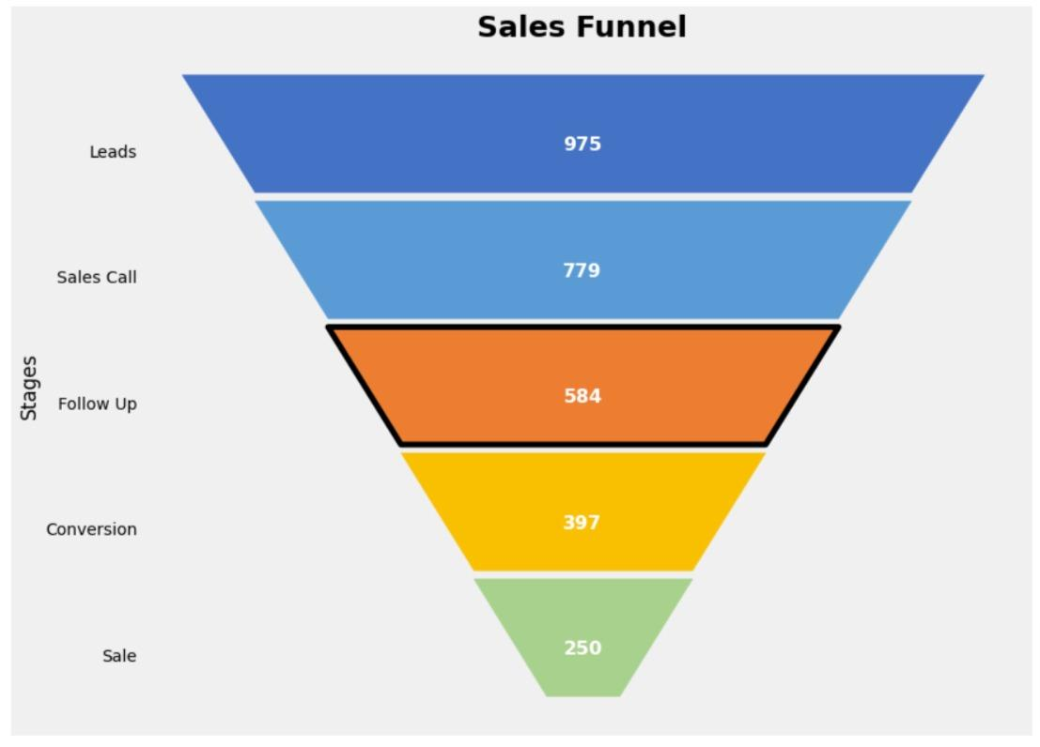
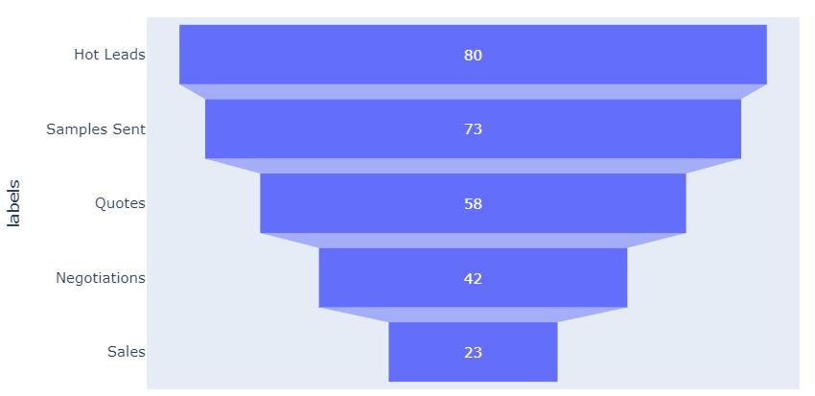
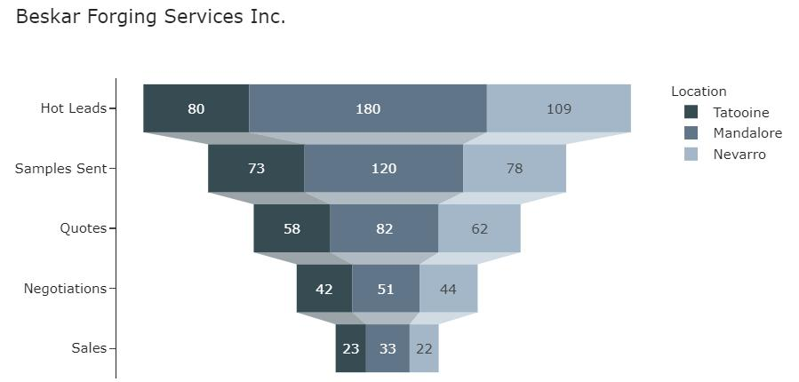
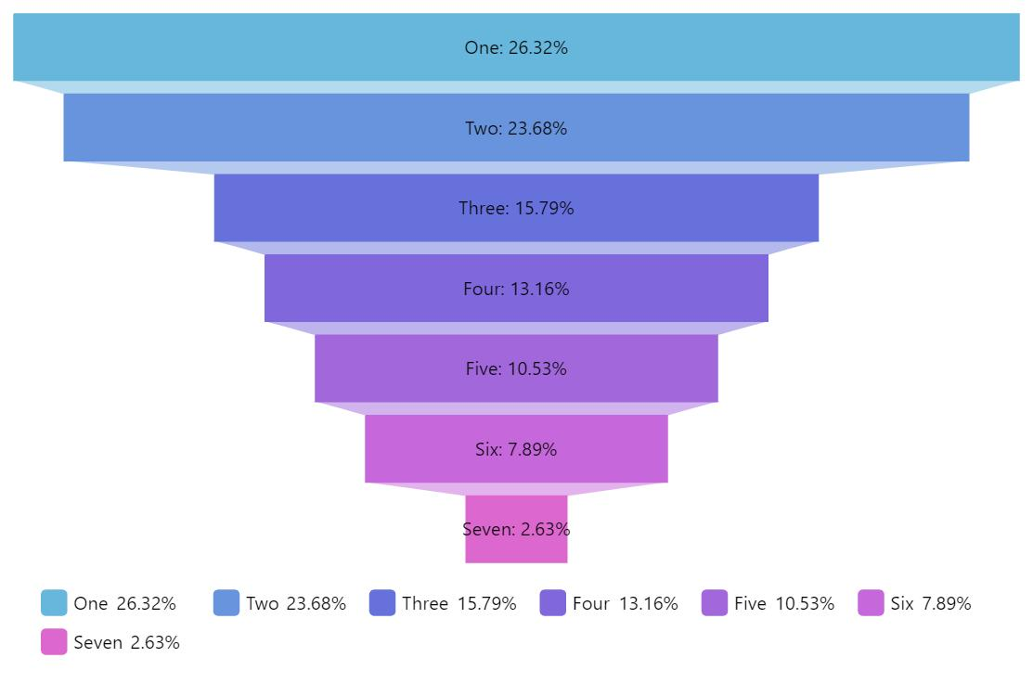
Program
import matplotlib.pyplot as plt

stages = ["Visit","Signup","Login","Purchase"]
y = [4,3,2,1]

plt.fill_betweenx([4.3,3.7], -50, 50, label="Visit")
plt.fill_betweenx([3.3,2.7], -40, 40, label="Signup")
plt.fill_betweenx([2.3,1.7], -30, 30, label="Login")
plt.fill_betweenx([1.3,0.7], -20, 20, label="Purchase")

plt.yticks(y, stages)

plt.xlabel("Users")
plt.ylabel("Stages")
plt.title("Funnel Chart")

plt.legend()

plt.show()

Functions Used
Function | Purpose
plt.fill_betweenx() | Creates filled horizontal regions
plt.yticks() | Sets stage labels
plt.xlabel() | Adds X-axis label
plt.ylabel() | Adds Y-axis label
plt.title() | Adds graph title
plt.legend() | Shows labels
plt.show() | Displays graph

Output Description
- Funnel chart is created using decreasing widths
- Shows user flow:
  - Visit → Signup → Login → Purchase
- Each stage decreases representing drop-off

Task 4 – Pyramid Chart using Matplotlib
A pyramid chart was created using layered horizontal regions.
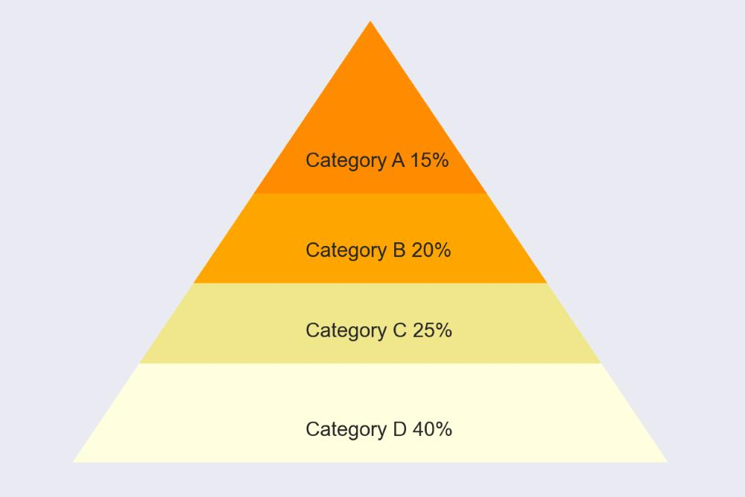
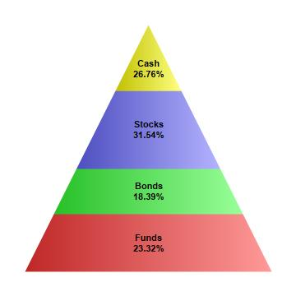
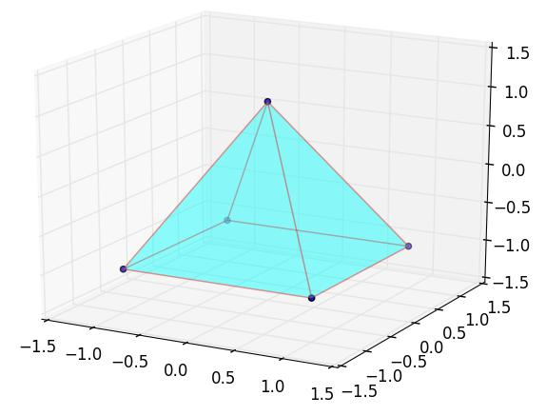
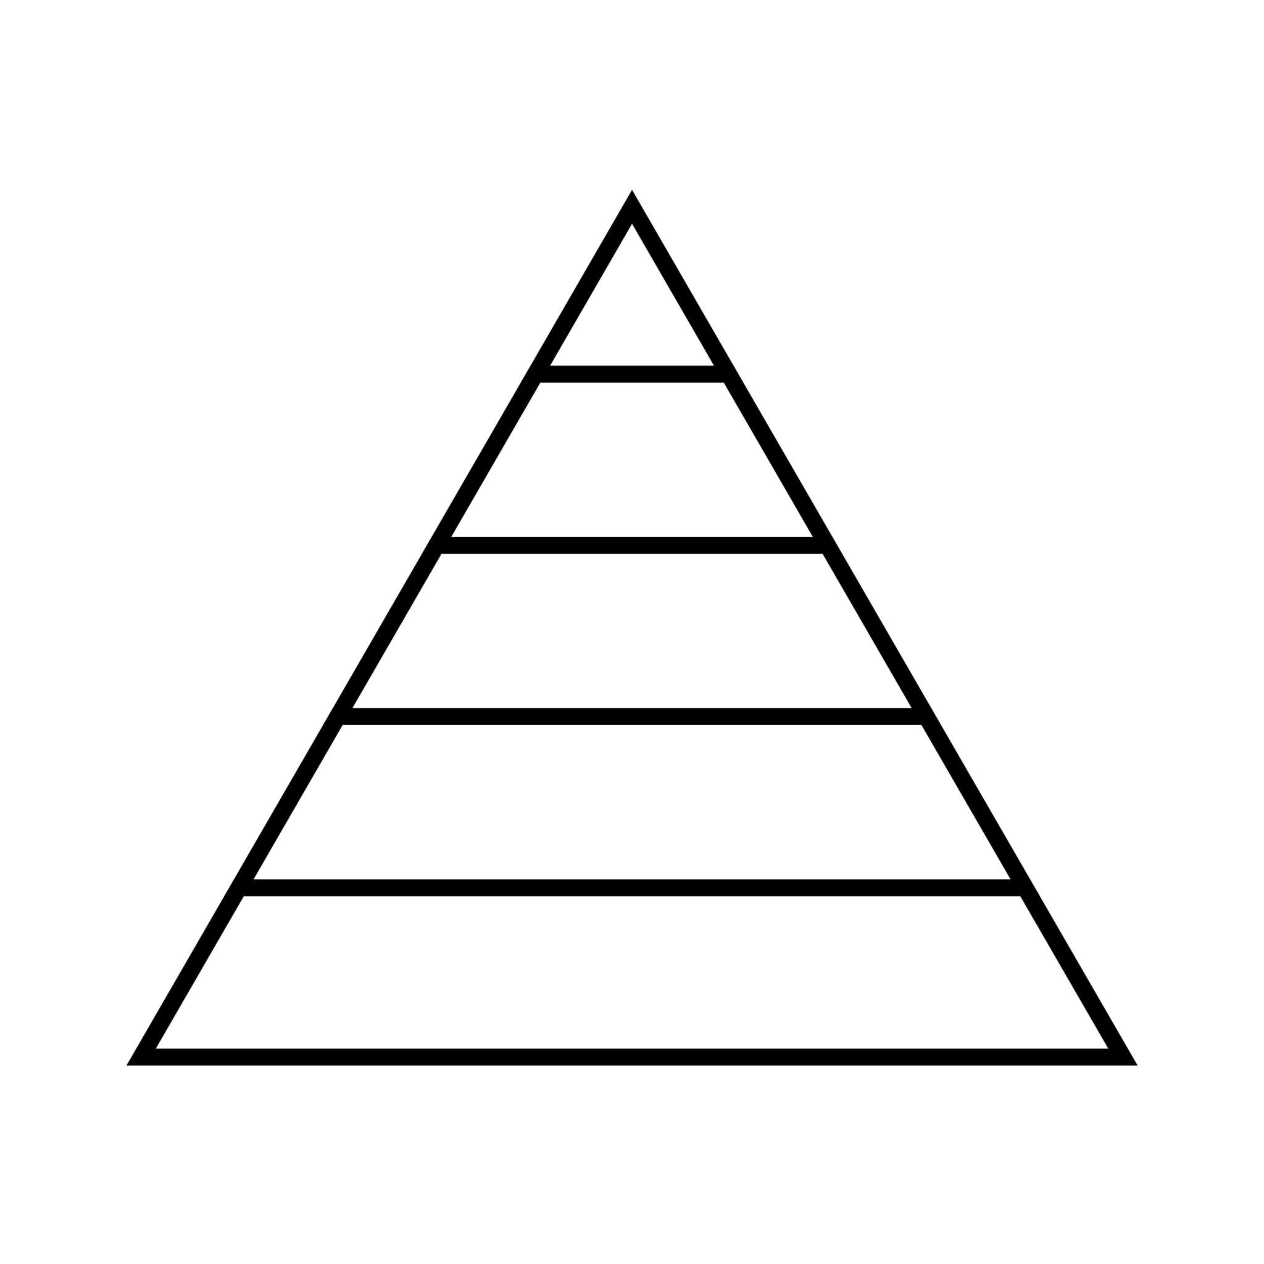
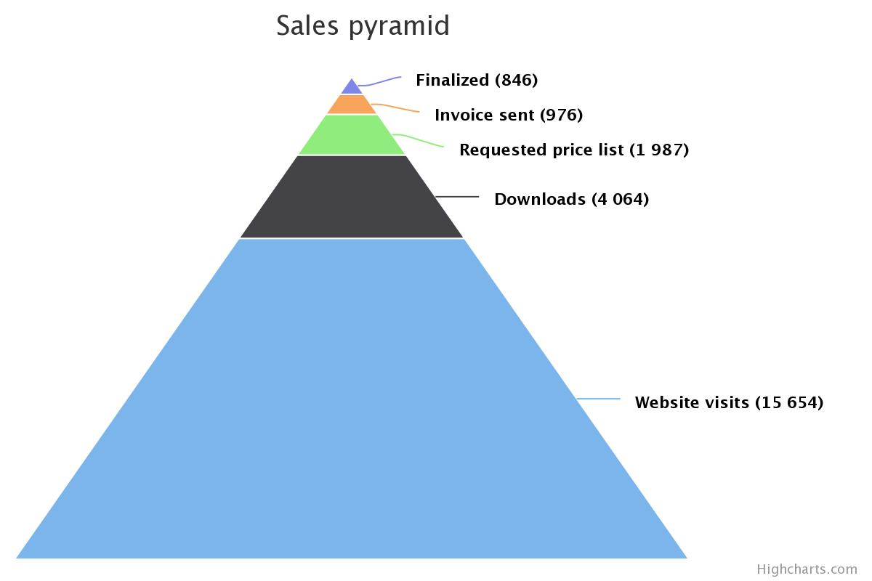
Program
import matplotlib.pyplot as plt

levels = ["Top","Middle","Lower","Bottom"]
y = [4,3,2,1]

plt.fill_betweenx([4.5,3.5], -10, 10)
plt.fill_betweenx([3.5,2.5], -20, 20)
plt.fill_betweenx([2.5,1.5], -30, 30)
plt.fill_betweenx([1.5,0.5], -40, 40)

plt.yticks(y, levels)

plt.xlabel("Values")
plt.ylabel("Levels")
plt.title("Pyramid Chart")

plt.show()

Functions Used
Function | Purpose
plt.fill_betweenx() | Creates layered pyramid structure
plt.yticks() | Sets level names
plt.xlabel() | Adds X-axis label
plt.ylabel() | Adds Y-axis label
plt.title() | Adds graph title
plt.show() | Displays graph

Output Description
- Pyramid structure is formed using layered blocks
- Each level represents a hierarchy
- Width increases from top to bottom

Technologies Used
- Python
- Matplotlib
- Google Colab
- Data Visualization

Learning Outcome
On Day 13, I learned how to create different advanced visualization graphs using Matplotlib.
I understood:
- how to compare datasets using line graphs
- how bubble charts represent data magnitude
- how funnel charts represent stage-wise reduction
- how pyramid charts display hierarchy structures
- how different plotting functions improve data visualization

Conclusion
The Day 13 internship session helped me understand advanced graph plotting and visualization techniques using Matplotlib. I created comparison graphs, bubble charts, funnel charts, and pyramid charts using different plotting functions.
This session improved my understanding of visual comparison, hierarchical representation, and graphical analysis techniques in Python.

